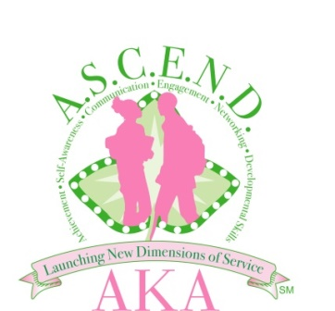
Dear Parents and Prospective Students,
Alpha Kappa Alpha Sorority, Incorporated recently launched our new signature program ASCEND℠. ASCEND℠ stands for Achievement, Self-Awareness, Communication, Engagement, Networking and Development. The primary goal of ASCEND℠ is to provide academic enrichment and life skills training leading to meaningful careers. The emphasis will focus on SMART (Science, Math and Related Technologies). We have just begun the recruitment process for students to participate in Cycle 2 of this program.
The Goals of ASCEND℠:
- Provide college preparatory workshops focusing on desired college major/career choices
- Promote positive self-esteem and confidence
- Provide study and test preparation skills
- Provide opportunities for cultural awareness and community engagement
Program Criteria for ASCEND℠ students:
- Application must be currently enrolled in 9th, 10th, 11th, or 12th grade and in good- standing.
- Applicant must maintain a C (2.0) grade point average.
- Applicant must submit his/her most recent report card.
- Letter of recommendation from counselor, teacher or community leader.
- Applicant must agree to follow the guidelines outlined in the Code of Conduct while participating in the program.
- Applicant must submit a completed parental consent form signed by the parent or legal guardian and the student.
This program will provide tools to enhance your child’s post high- school goals. We invite your participation!
Sincerely,

Patrice Marshall McKenzie, Program Chair
Toni Jones - ASCEND℠ Chairman
Yanique Johnson - ASCEND℠ Co-Chairman
